**LAB-EXERCISE:**  **RIYA INDAP,44**

1.Write an AWK script to develop the fibonacci series.

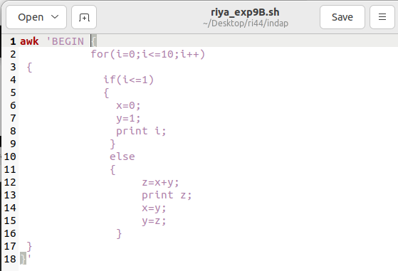

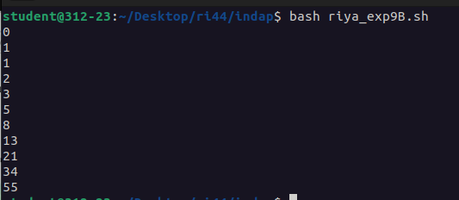

2.Write an AWK script to replace the Nth occurrence of a pattern.

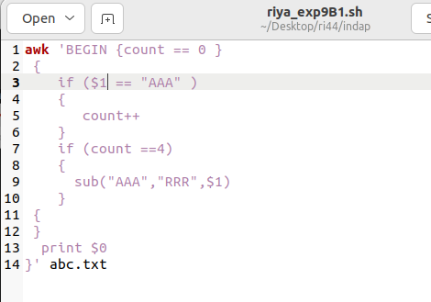

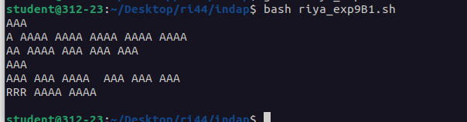

**POST-EXPERIMENT**

1.Write a AWK script to print only a certain columns from the input fields.

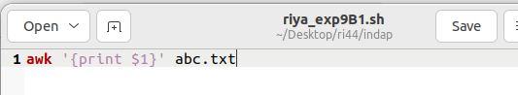

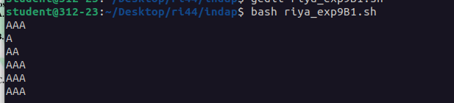

2.Write an AWK script to display a pattern from a file.

